Question 1
Recreate the following website using HTML elements. The website has a header containing an H2 header and a navigation link. The main section contains an H1 header, and some content. There is also a footer with some content.
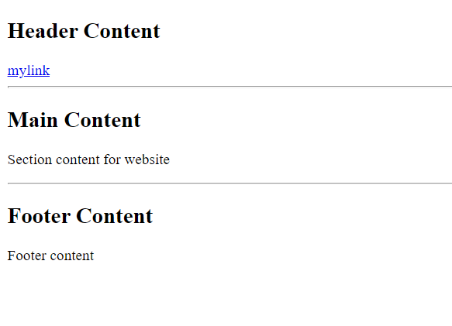
- Apply CSS styling to set all H2 headers to blue.
- Add a CSS styling to set only the heading for Main Content to green using a class called main.
- Add a CSS styling to set only the paragraphs in main and footer to yellow. Use a class for this.
- Using an ID, add a CSS styling to align the content of all text the main content to center.

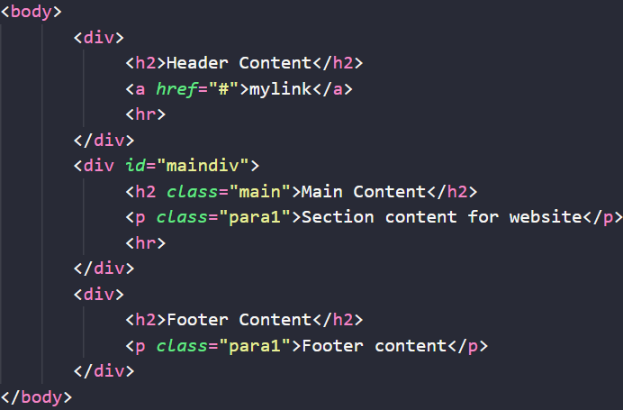
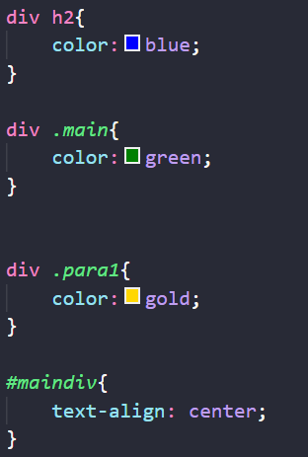

Question 2
You have the following HTML
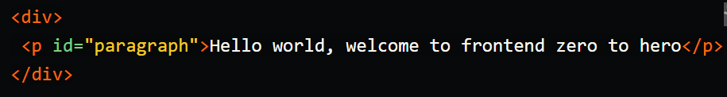
And the CSS is as follows:
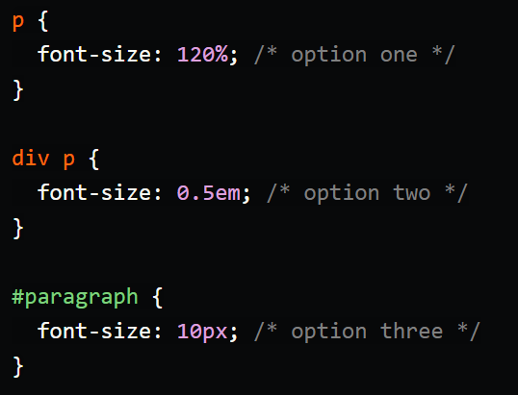

State the font-size that will be applied, and justify why.

